1. What is Route 53?

Whenever user hits the url [www.jhooq.org](http://www.jhooq.org) it wil goes to DNS server i.e R53 it will try to resolve the request based on the name server setting. Once it resolved the request will forward to resource which is configured in EC2 instance , this request forwarding happening with the A-Record type.so we need to configure the below 2 components :

1.) Name server Record - For resolving the domain

2.) A-Record type – forwarding that particular req to the particular resource.

Note : we can send the request to any of the below shown resource like Ec2 , fargate,ECS,K8s , here we are using EC2.

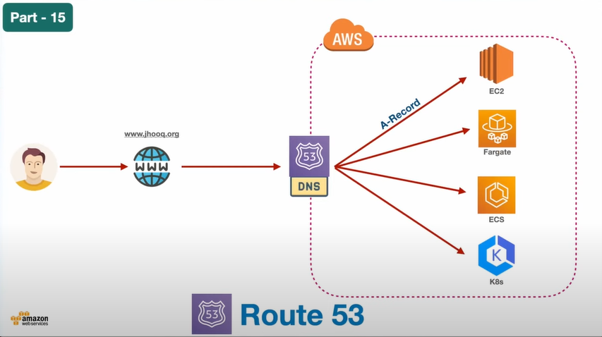

1. How to set up Hosted Zones inside Route 53

Lets assume we have a test.xyz website purchased from Godaddy or google doamins and for this we need to create a Hosted Zone for this website

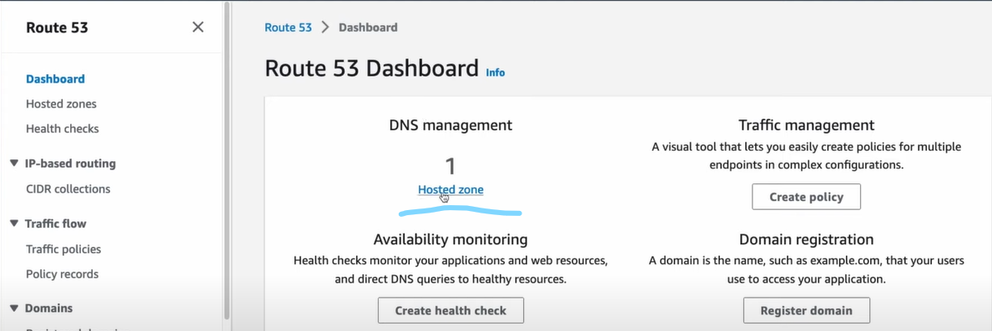

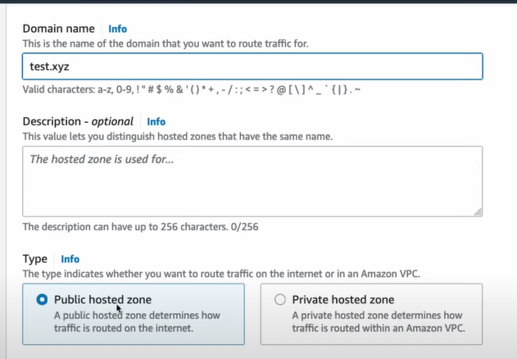

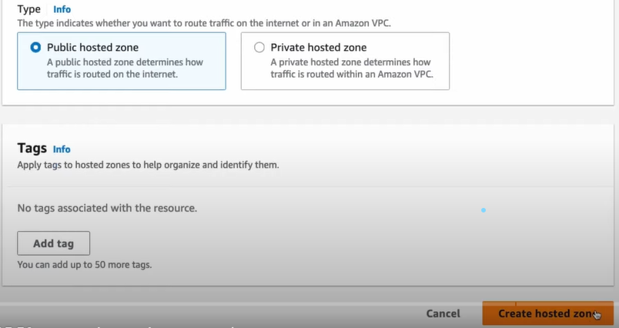

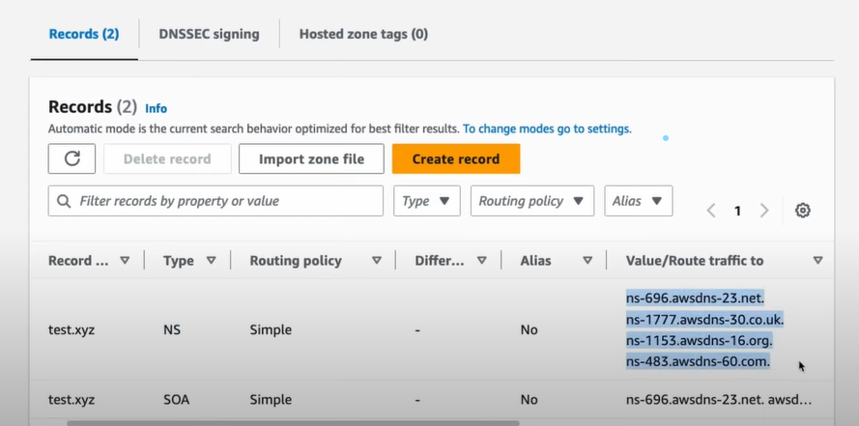

1. How to create custom Domain and how to integrate with AWS Route 53

Already we have a website i.e custom domain called [www.jhooq.org](http://www.jhooq.org) purchased form google domains for this we have already created hosted zones and the NS record values present in AWS R53 should be copied to google domains custom name servers.

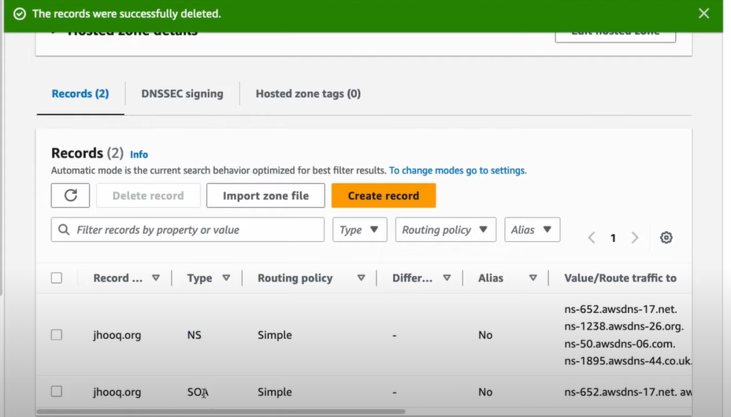

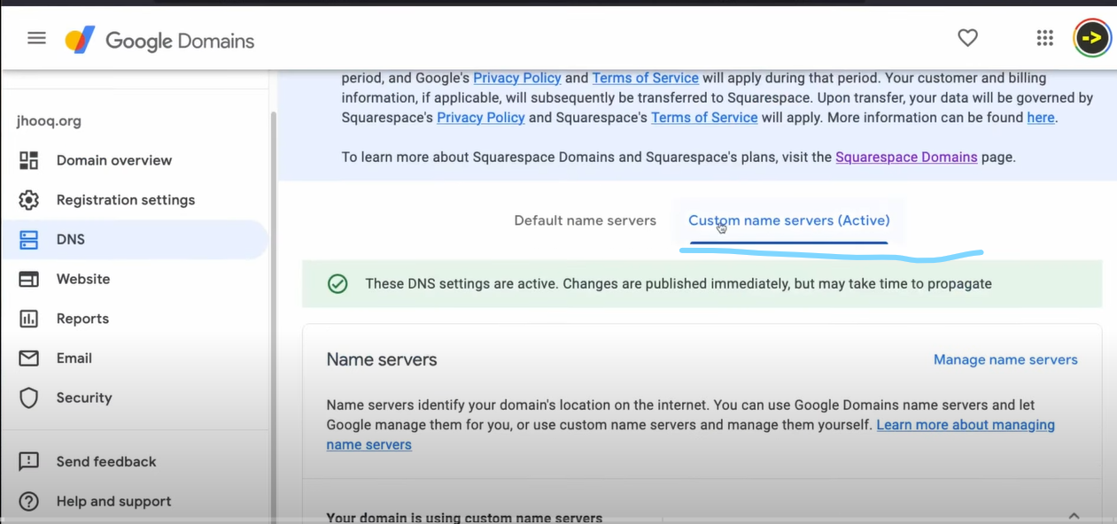

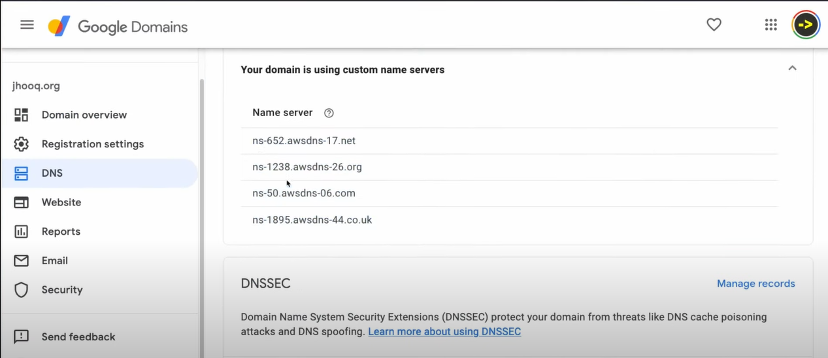

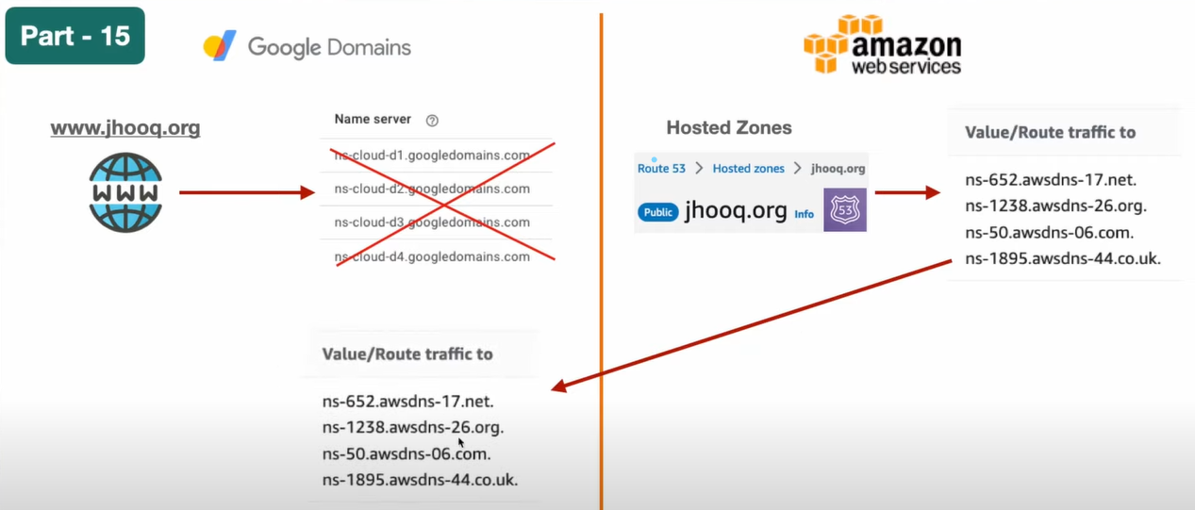

1. What is Name Server, A Name record, CNAME record and ALIAS record.

Create any EC2 instance and allow ssh 22 and http 80 ports for connecting to that server and access to the webserver (apache httpd server) that got installed into this server .

Auto enable public ip .

Now access this server with public ip

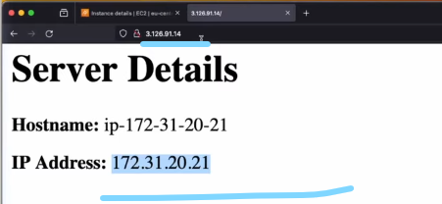

Here we are accessing the server (apache server home page)with public ip but we shouldn’t do like this instead we need to access the apache server home page with [www.jhooq.org](http://www.jhooq.org) , for this we need to create a A record type in R53 hosted zone to point out to this particular Ec2 instance.

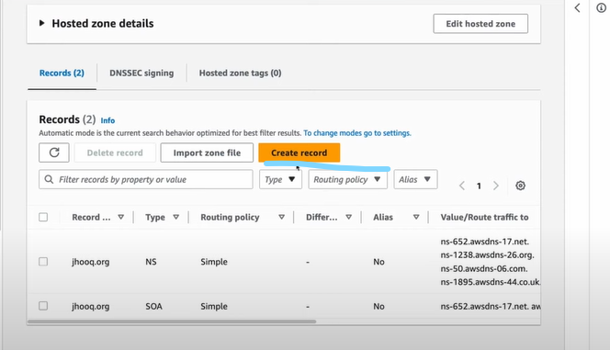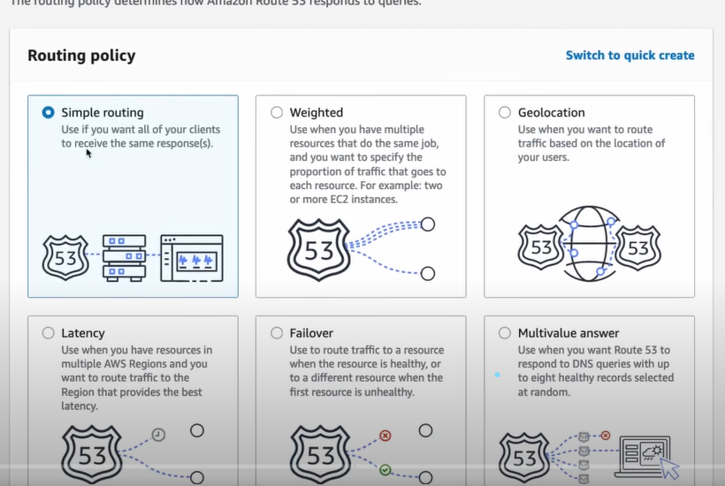

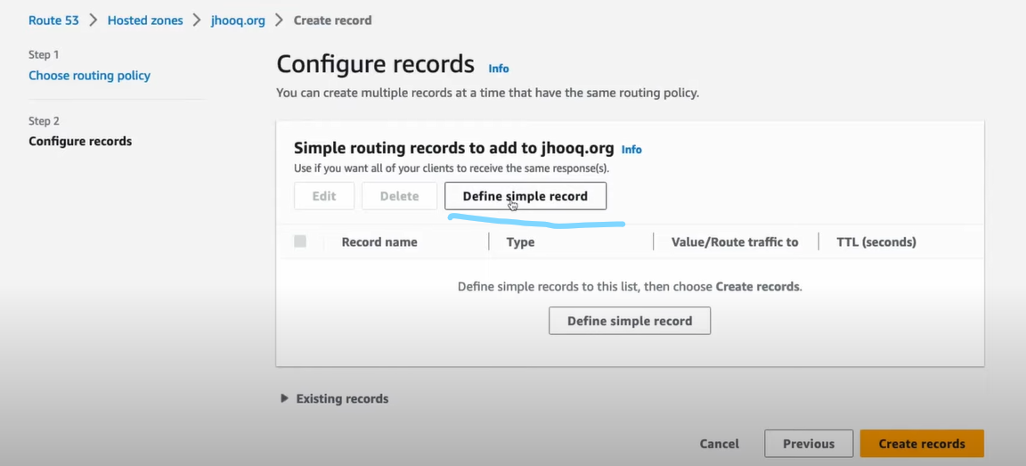

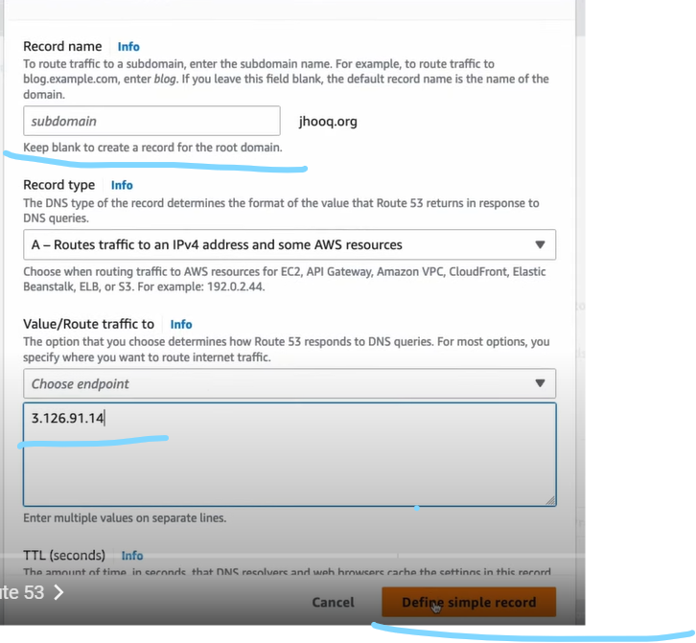

In the above keep the sub domain empty since we are not having sub domain.

Provide the Ec2 instance public ip address in the endpoint.

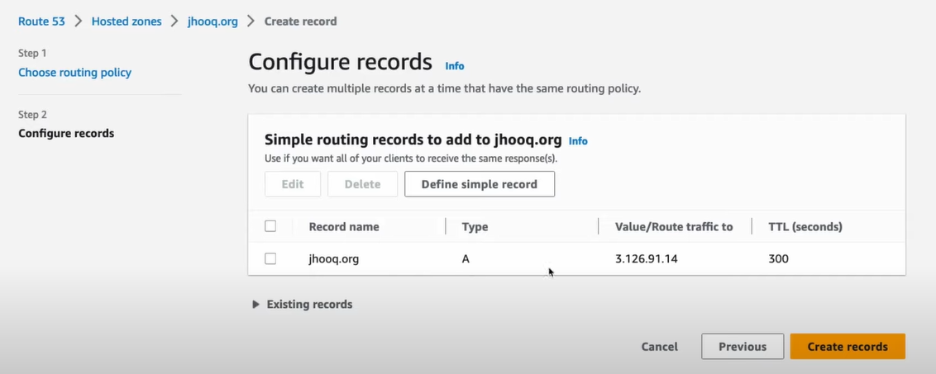

Edit the record and change the TTL to 10seconds for testing purpose.

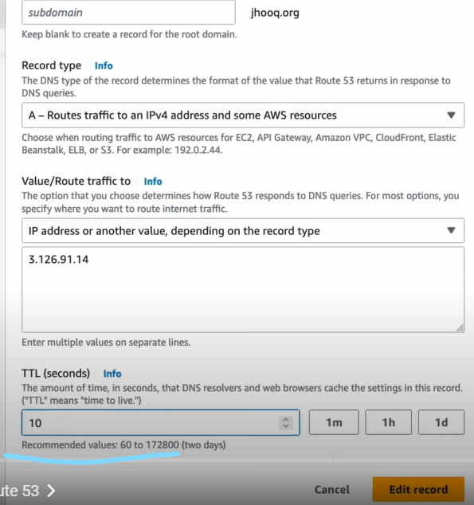

Now select the record and click on create record.

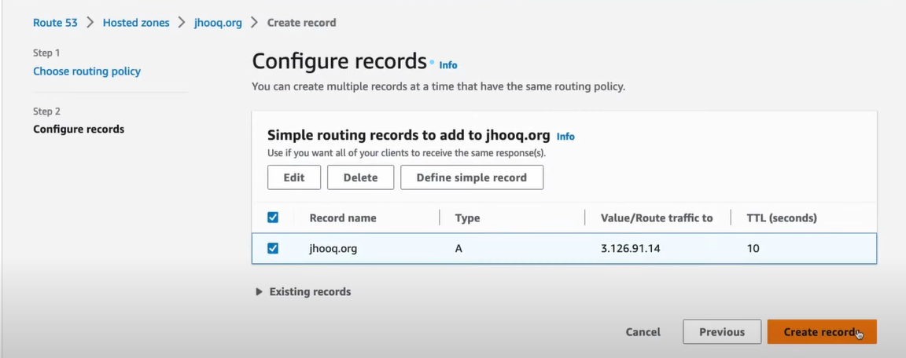

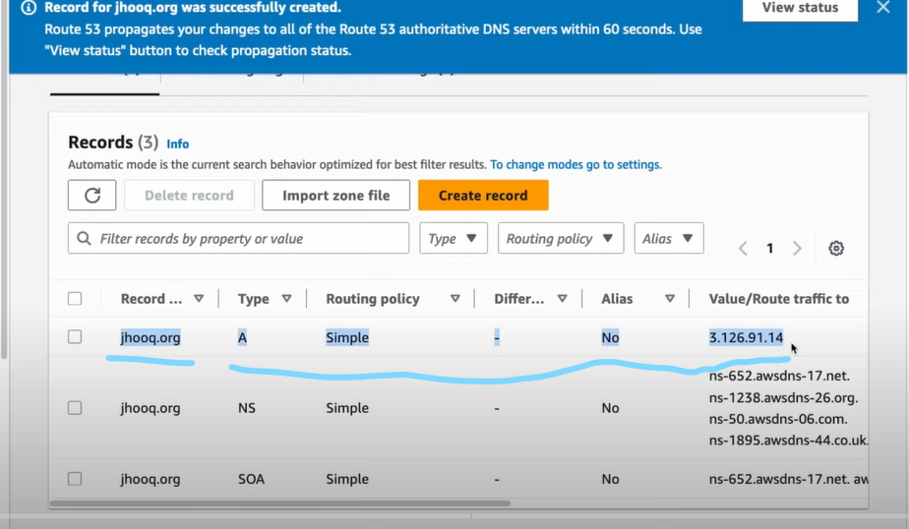

Now access the Ec2 instance with the custom Domain [www.jhooq.org](http://www.jhooq.org)

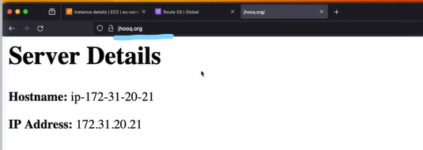

Routing Types?

1. Simple Routing

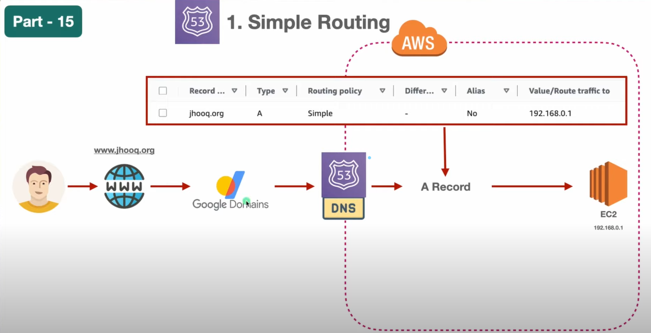

So here we have 1 problem if we change the Ec2 instance then we must change the ip address in A Record Type as well which is not a good practice to use the static ip in the A Record Type so, solution is Load Balancer.

First, we need to create this infra before creating Load balancer.

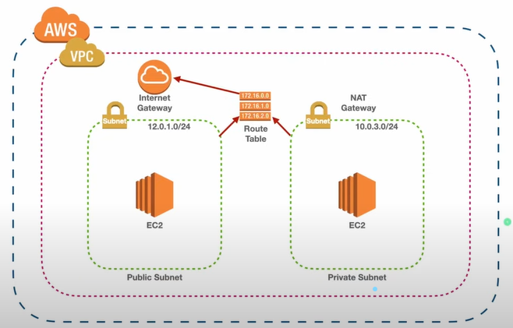

Crate VPC 12.0.0./16 (65,536), Create 3 Subnets

in which 2 are public 12.0.1.0/24 (256 IPs), 12.0.2.0/24 (256 IPs), and 1 is private 12.0.3.0/24 (256 IPs)

Create IGW and attach it to the VPC.

Create Route Tables for both the Subnets.

Create Route Table for the Public Subnet

Go to subnet Associations and select only the public subnets.

Click on Edit Routes and add the IGW because any one from internet can access this Public subnet.s

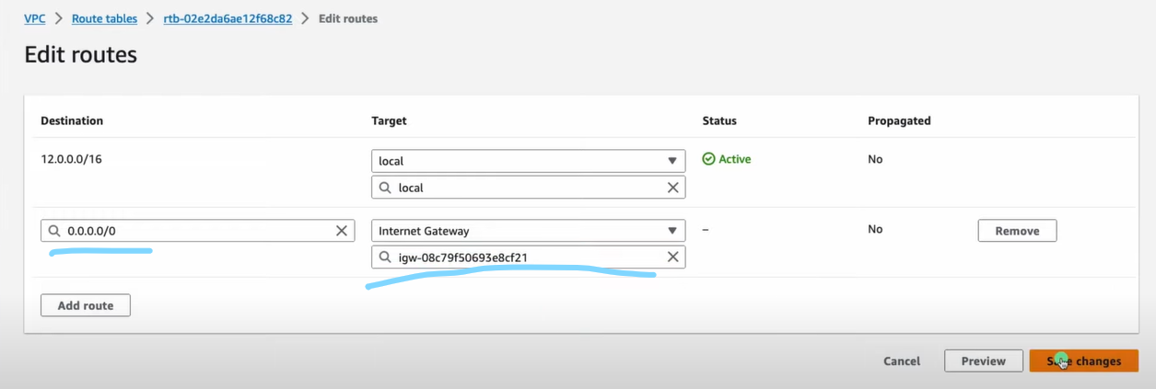

Create Ec2 Instance in public subnet and enable SG ports for ssh 22 and HTTP 80 for apache HTTPD S/w in user data.

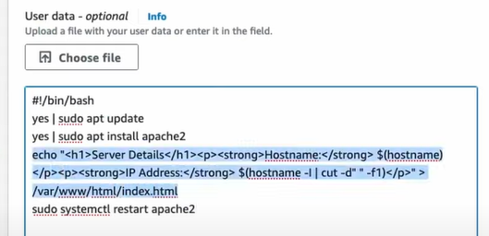

Create Route Table for the Private Subnet

Go to subnet Associations and select only the Private subnet.

VV.IMP: In Private subnet we shouldn’t add IGW in route table.

Now we need Create Target Group

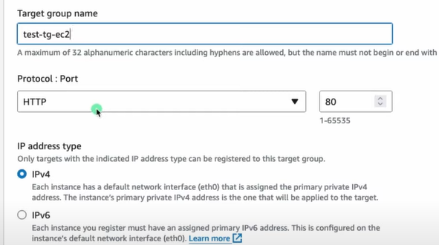

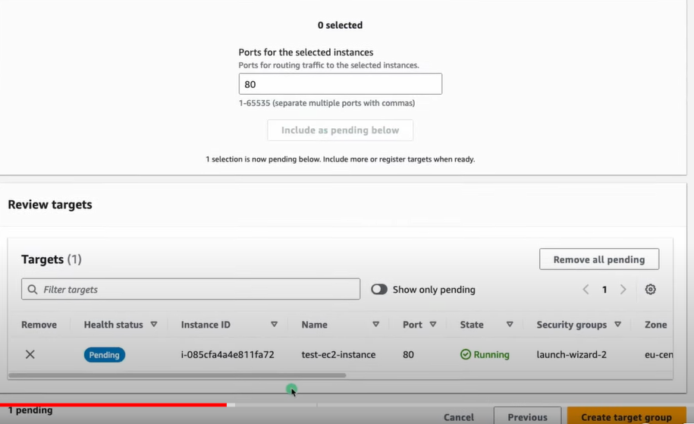

Now create ALB.

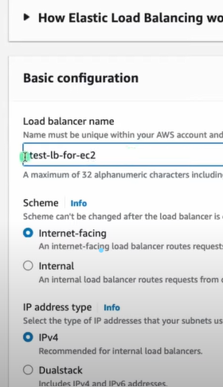

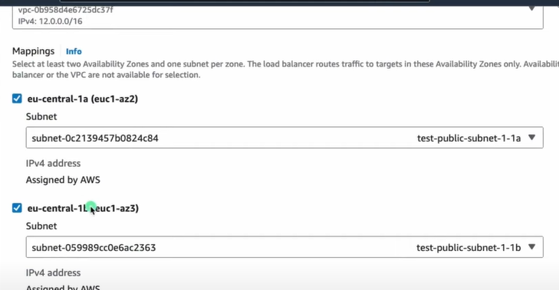

Create SG for ALB and enable SG ports for ssh 22 and HTTP 80 for apache HTTPD

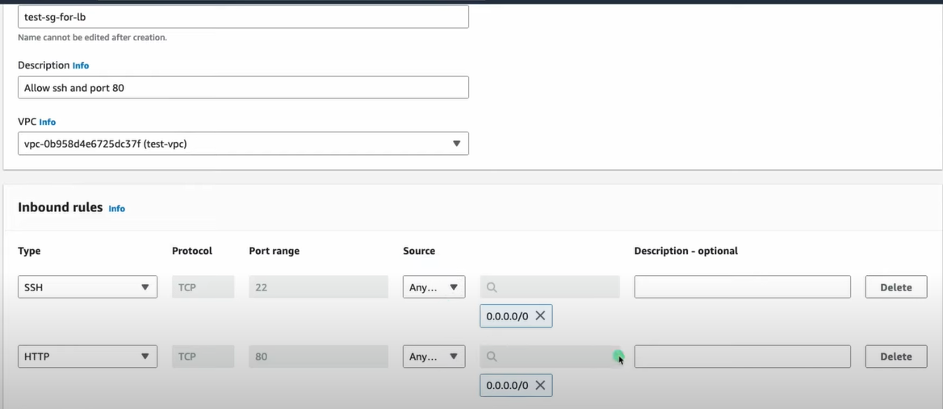

Now configure the Target Group we have created in Listener and Routing section of ALB.

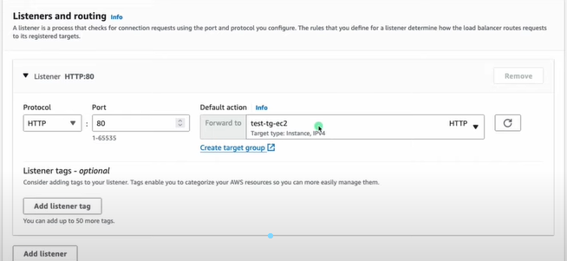

Copy the DNS Name of the ALB and hit enter

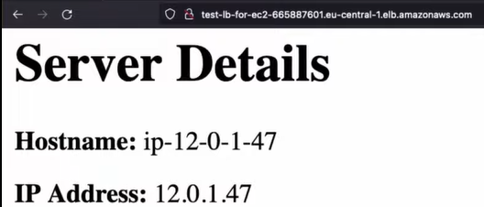

Now go to R53 and delete the A Name record type which we have created earlier.

Now create new record

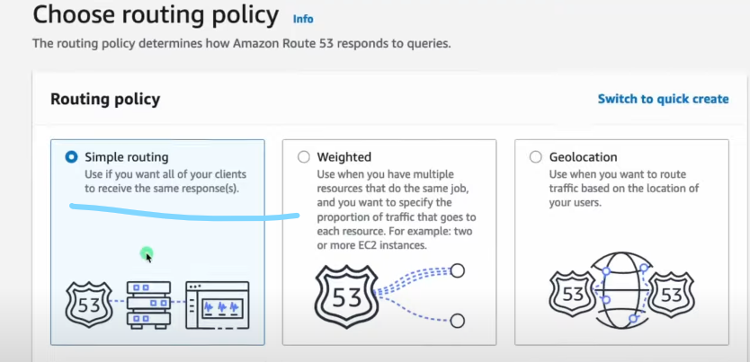

Select the ALB which we have created just now

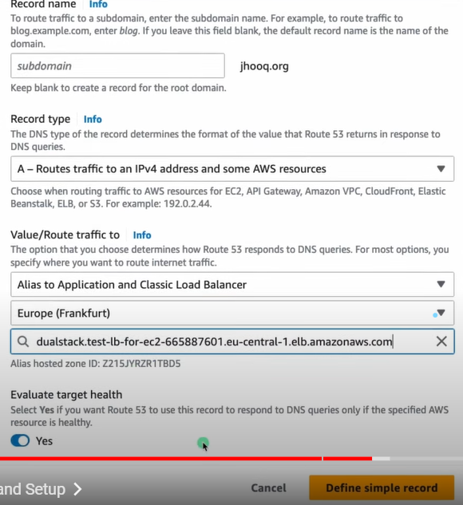

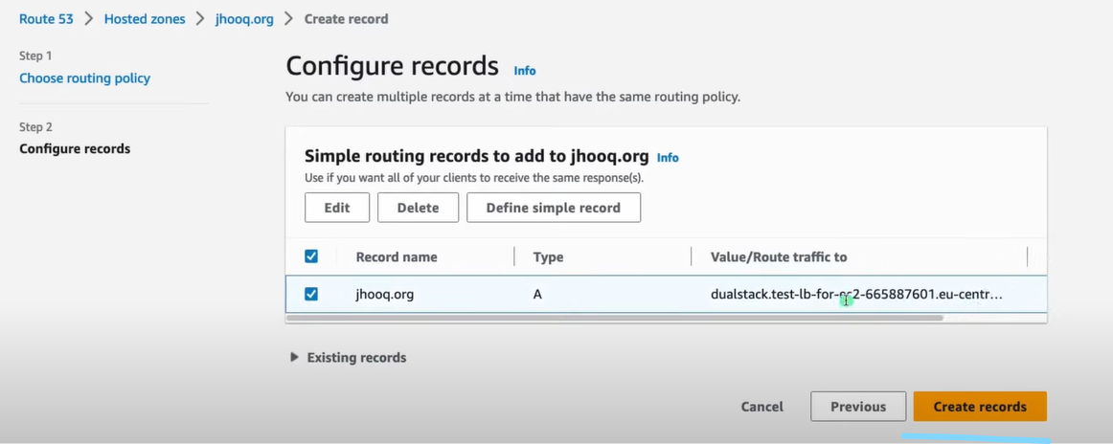

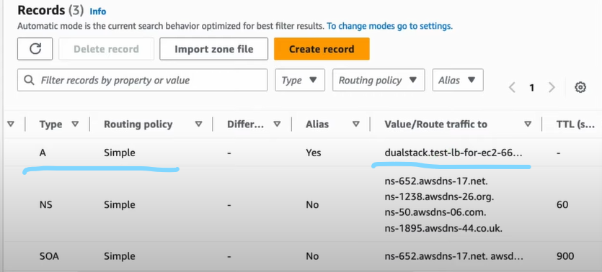

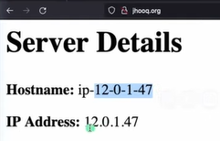

1. Weighted Routing:

We will define the percentage of traffic to be routed to each ALB in Weighted Routing.

Basically we have more than 1 ALB in Weighted Routing so it will divide the traffic b/n them and forward it to the Ec2 instances .

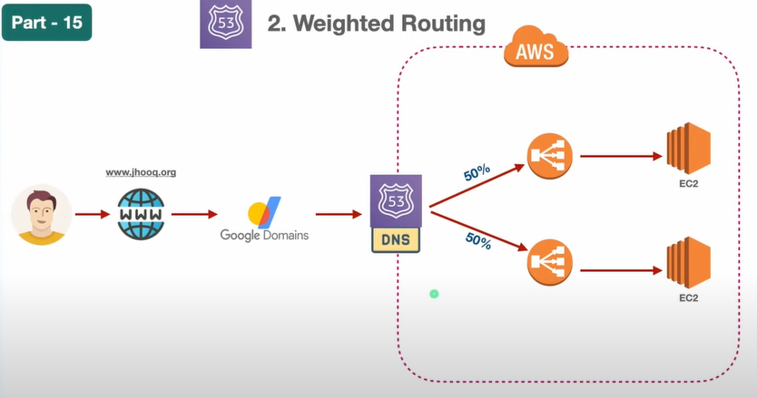

Create another VPC with Range 13.0.0.0/16 , Subnets , IGW and Route Tables like we created above .

Create Ec2 instance in Public subnet.

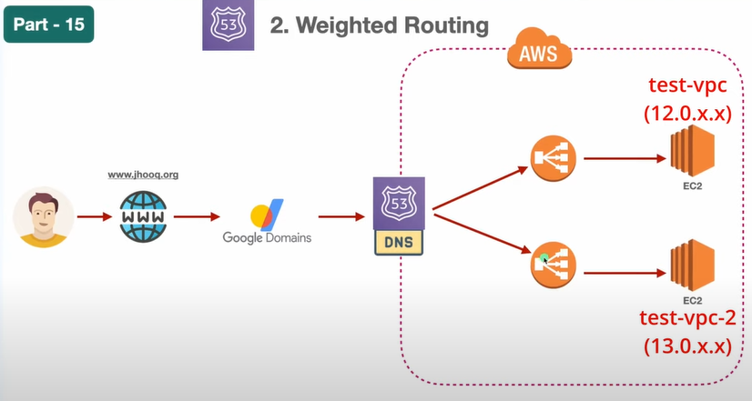

Create Target Group like we created above.

Create ALB like we created above and select the Target Group

Now Create A Record in R53 so that we can divide the traffic 50-50 B/N the 2 ALBs.

First delete the A Name Record which we created for single ALB.

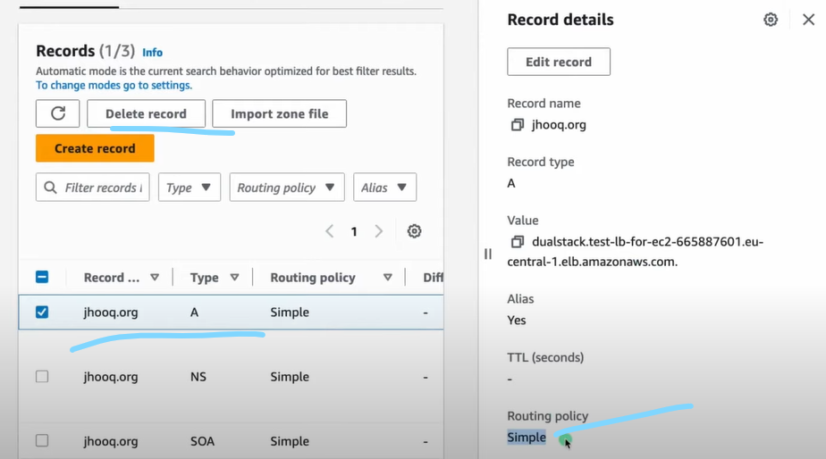

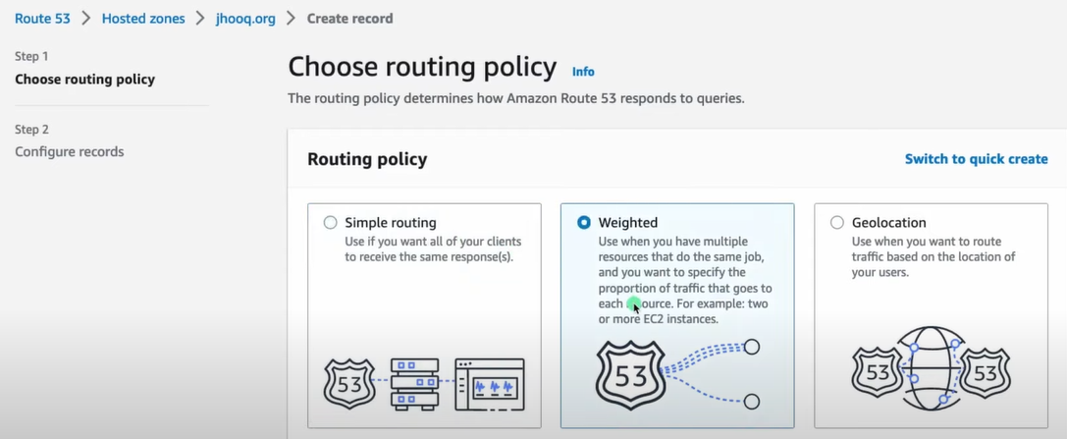

Here weight is represented b/n 0 to 255 so for 50% we have given 128.

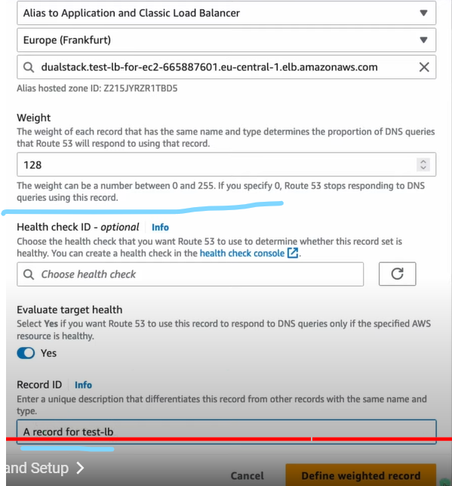

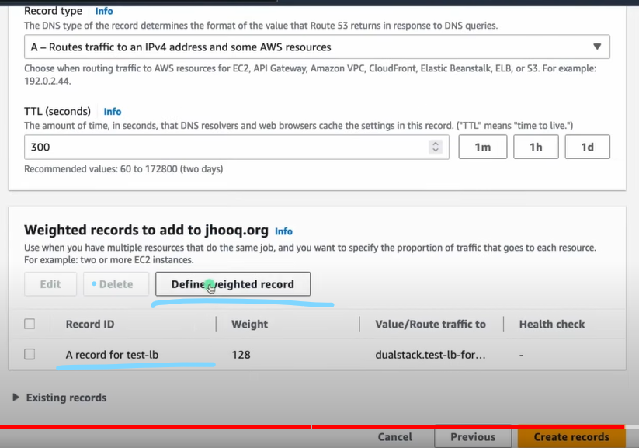

Similarly create for 2nd ALB.

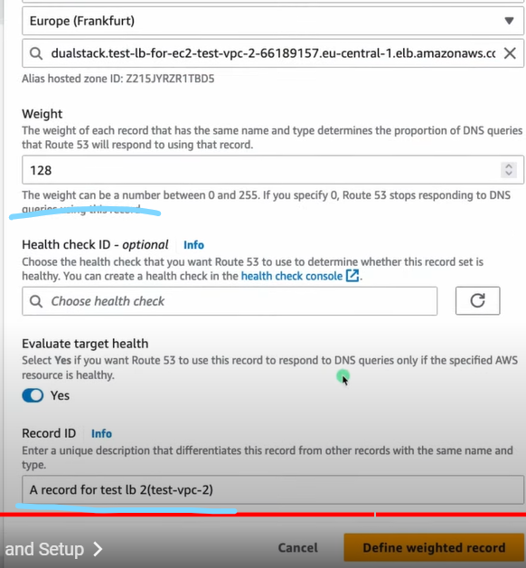

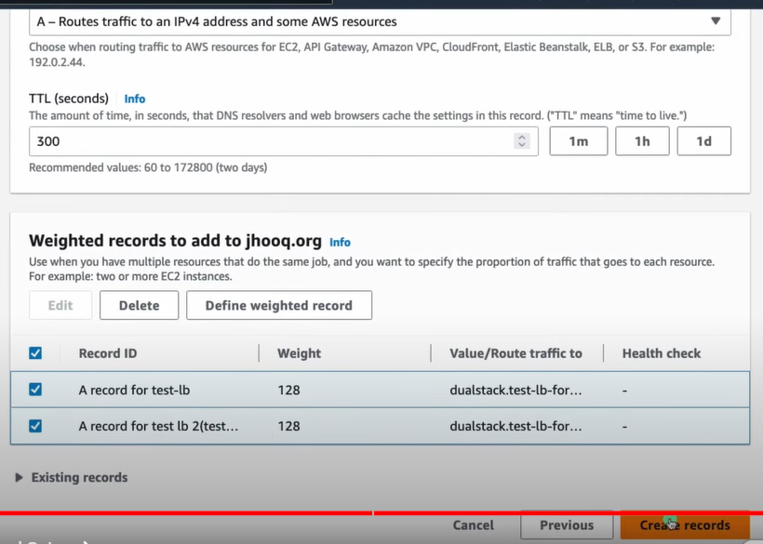

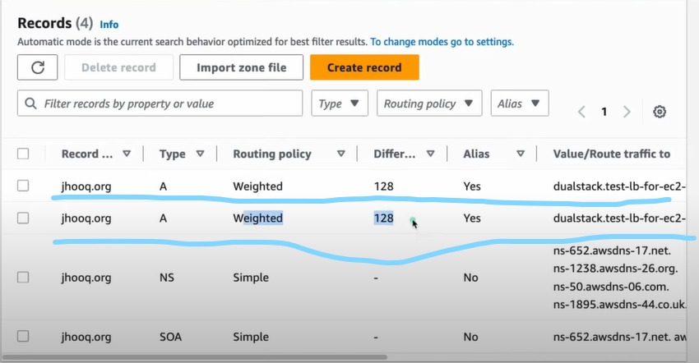

1. Geolocation: depends on from which location the requests coming

Set up is same as weighted policy Instead of weighted Record we need to create Geolocation records.

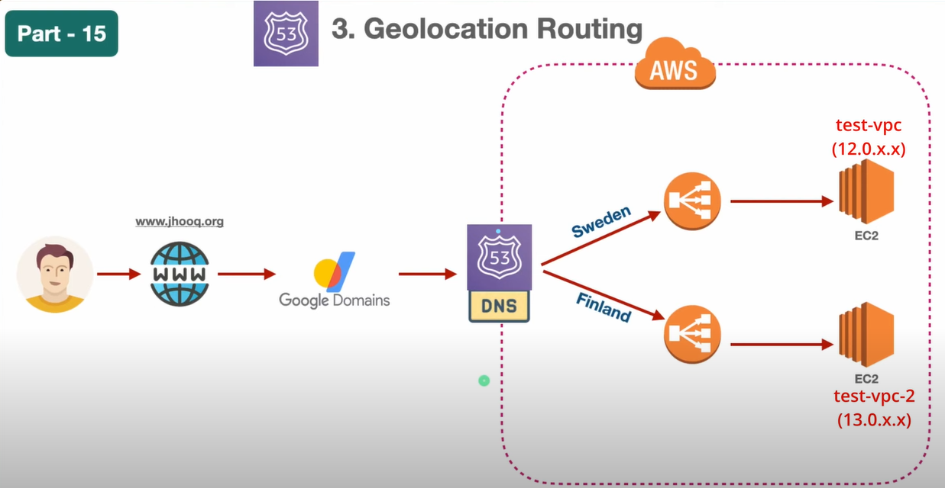

Delete weighted Records and create Geolocation records

Select Sweden for 1st ALB.

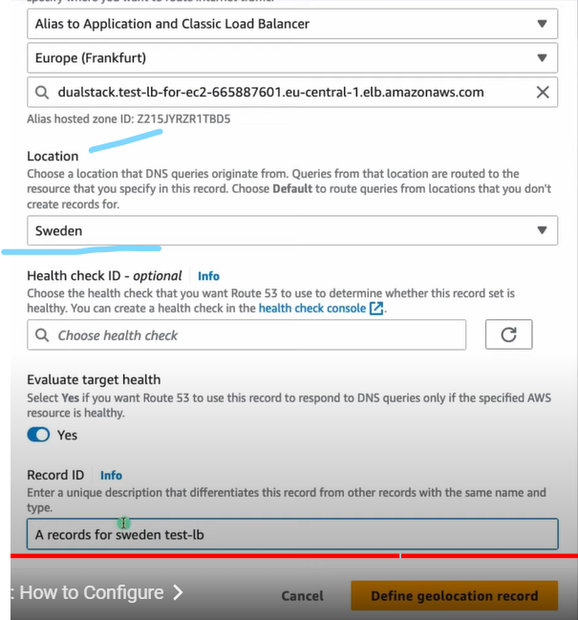

Similarly select Finland for 2nd ALB.

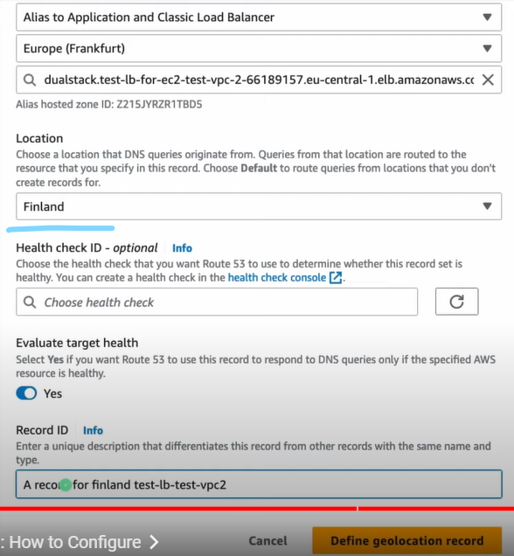

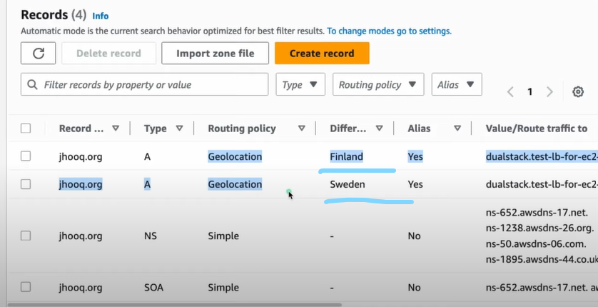

To test this we have VPN(Nard VPN) and connect to SWEDEN VPN and hit the site and see the IP address is from Sweden Ec2 instance .

1. Failover

Here we need to define the Primary record type with the ALB Details since if in case any Ec2 instance Fails then the traffic will route to the Primary ALB.

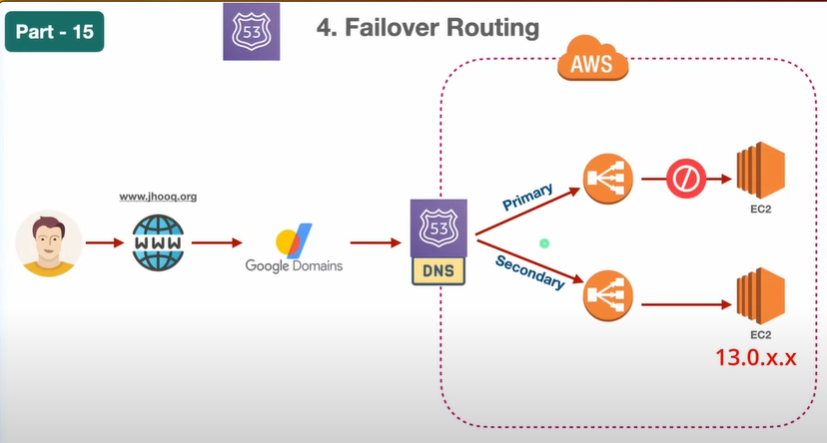

Delete the geolocation Records and create Failover Records

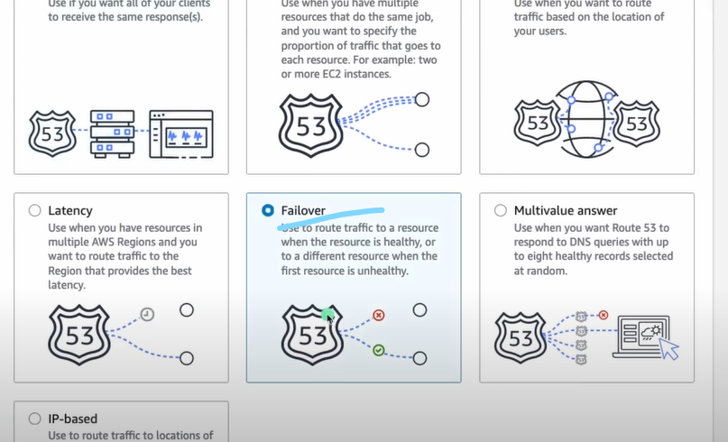

Select primary record type

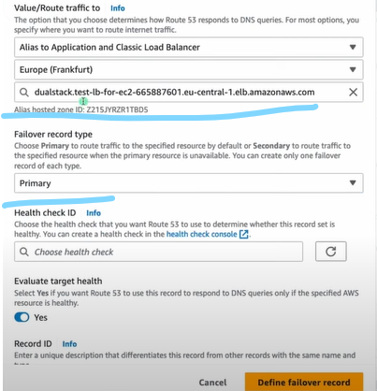

Similarly secondary record type

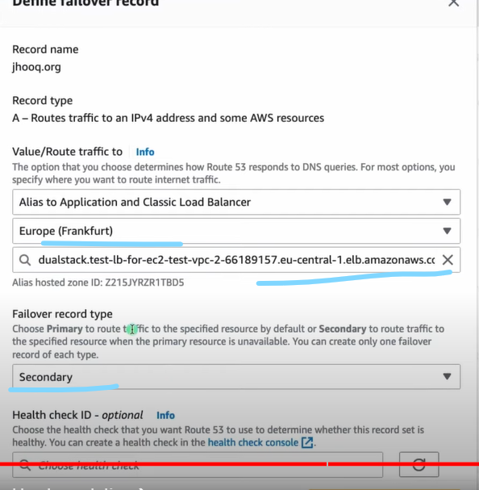

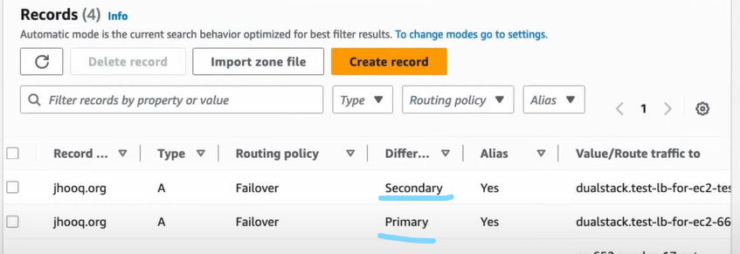

Now to test this stop/terminate the Ec2 instance in the 1st ALB , then hit the URL req will go to the Ec2 instance in 2nd ALB.